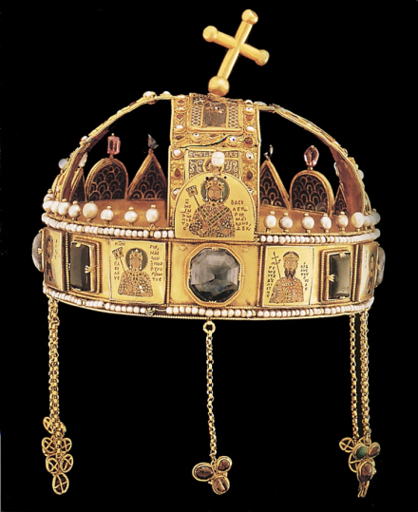
The Byzantine Commonwealth 50 years on:
Empires and their afterlife
Programme
Thursday 27 September / Friday 28 September 2018
Linbury Building, Worcester College, Oxford
THURSDAY 27 SEPTEMBER 2018

9.00 Peter Frankopan (Oxford)
Welcome and Introduction – Obolensky’s Commonwealth 50 years on
I. Afterlife and other empires (Chair: Peter Frankopan)
9.30–11.00 Hugh Kennedy (SOAS)
Sasanian afterlife: Iranian cosmology and political culture in the tenth-century dar al-Islam
David Morgan (University of Wisconsin–Madison)
The Mongols as agents of cultural exchange
Nicola Di Cosmo (IAS, Princeton)
From war to peace in medieval steppe empires
11.00–11.30 Coffee
II. A commonwealth of things? (Chair: To be confirmed)
11.30–1.00 Peter Sarris (Cambridge)
Byzantium’s empires of gold
Marcin Wołoszyn (Leipzig)
Finding the frontiers of the commonwealth
Cecily Hilsdale (McGill)
The Byzantine visual commonwealth
1.00–2.00 Sandwich lunch
III. Elites on the fringe… (Chair: Marek Jankowiak)
2.00–3.30 Jean-Claude Cheynet (Paris-Sorbonne, UMR 8167 « Orient-Méditerranée »)
Les élites des provinces frontalières de l’Empire, adhésion ou trahison
Tim Greenwood (St Andrews)
The Byzantine commonwealth: a view from the east
Vlada Stanković (University of Belgrade)
Byzantine reclaiming of southeast Europe or a study in Byzantine soft power, 9th to 14th centuries
3.30–4.00 Coffee
IV. …and beyond the fringe (Chair: James Pettifer)
4.00–5.30 Monica White (Nottingham)
Late Byzantine views of Rus beyond the church
Kirill Maximovich (Göttingen/Frankfurt am Main)
Political culture of early Rus’ vs. the Byzantine law: two contradicting ideologies and means of their reconciliation
Marie Favereau (University of Oxford)
Byzantium and the Golden Horde: war, trade, and diplomacy
7.00 Conference dinner
FRIDAY 28 SEPTEMBER 2018
V. Law and ideology (Chair: Averil Cameron)
9.00–10.30 Daphne Penna (University of Groningen)
Keeping up appearances: Byzantine perspectives of ‘legality’ and the Italians
Michael Humphreys (Cambridge)
Identity, law and beards: judicial shaving in Byzantium, c. 600–900
Johannes Pahlitzsch (Mainz)
Translations of Byzantine law books into Arabic
10.30–11.00 Coffee
VI. Inward and outward impulses (Chair: James Howard-Johnston)
11.00–12.30 Juan Signes Codoñer (Valladolid)
Identity through language in Byzantium and its neighbours
Nick Evans (Cambridge)
Boundaries and bonds: Khazaria and the ‘commonwealth’
Sergei Ivanov (Moscow)
The reluctant empire
12.30–1.30 Sandwich lunch
VII. Magnetism, exclusivity and diplomacy (Chair: Jonathan Shepard)
1.30–3.00 Paul Magdalino (St Andrews)
Byzantine globalism: the power of attraction
Shay Eshel (Hebrew University of Jerusalem)
A commonwealth of elect nations: contradiction in terms?
Jonathan Shepard (Oxford)
Conclusions – Commonwealth(s) without end?
3.00–3.30 Coffee

